Student’s Name
Instructor’s Name
Course
Date
Different Styles of art
According to Riemer et al. (10), Pieter Bruegel the Elder was renowned for naturalistic artwork. Naturalistic art is the portrayal of realistic objects in a natural setting. According to Kalmanowitz (75), this particular artwork is focused on ordinary and unflattering situations; everyday life; often the ugly and harsh circumstances of poverty and social conditions of the working class; unadorned and crude.
Naturalistic and realistic art is pulling away from the romanticism and spiritual art of the previous era in which life was idealized with “busty nudes, classical or mythological settings and royal decoration. Pieter Bruegel’s Hunters in the Snow is the realistic depiction of winter during his lifetime and his paintings have many vignettes with a lot to see (Riemer et al., 22). In the foreground the hunters have returned with meager results of one rabbit and they all look tired and forlorn; while in the background are scenes from everyday life. In opposition to the hunters’ bleakness, others are playing on the frozen ponds with hockey sticks and curling; going about their daily routines gathering wood and tending fires; one person can be seen putting out a fire on the roof of a house. Even further, the scene spans the horizon of the Alps – the realization of a harsh and cold winter day (Araslı et al., 175).
In The Harvesters there is, again, a lot to see. The peasants are working in the fields scything the wheat; tying it into bundles; and the females carrying away the bundles. Others are partaking of lunch and resting. Even though the figures are small, some of their faces can still be seen and even the food they are eating can be identified – cheese, bread, porridge and pears picked or fallen from the trees nearby. Following the winding road into the background toward, again, an expansive horizon with ships sailing on the river; the houses in the village; the monks swim in the pond; and people playing in the fields (Araslı et al., 178).
In Return of the Herd, the herders are bringing the cows in from the fields driving them with sticks. Again, the horizon goes far and deep with darkening clouds and shadows which indicates that this scene is most probably occurring in the evening time. In the background there is a winding river and what appears to be a small ship on the river; other houses on the river bank of the opposite shore; and on the small hillock there is a group of people working in the field. A small castle can barely be seen on the side of a mountain overlooking the river (Kalmanowitz 83). Basically, there are 3 main ways of representing art: Naturalistic, abstract and nonrepresentational art. Of the three, naturalistic is the oldest type and has been used since the age of the cavemen. This essay attempts to explain and differentiate the 3 styles of art as well as their differences.
Naturalistic art is also known as representational art. From the word represent we can see that this type of art presents again the visible world in such a way that we recognize a likeness (Araslı et al., 180). This type of art therefore attempts to represent objects in the same way as we would see them in nature. We therefore are able to recognize the likeness of the objects portrayed and forms. An example of representational art is Gutsave Caillebotte’s a rainy day in Paris which is part of Painter’s Eye collection. The painting is currently at the National gallery of art.
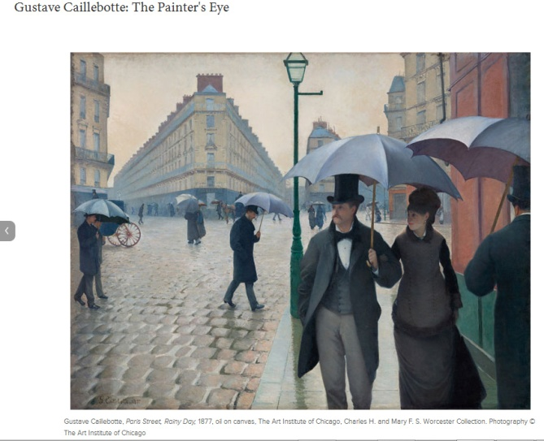
The painting is exceptionally real. It shows people walking through the streets of Paris in the 19th century. They are holding umbrellas which suggest that it is raining. Rain is further emphasized by the wet road in the painting. The sky is dull and grey further serving as evidence of the rain. The couple in the foreground seems to be looking at something to the right. A passing chariot perhaps? According to the national gallery of art Caillebotte was thrilled by the impressionists’ fresh, radical vision (www.nga.gov). He thus submitted paintings of people he met in and around Paris in their exhibitions. His paintings show that he was an artist who was interested in his surroundings and the environment that he was in. This is mainly why his work almost entirely consists of naturalistic art.
Abstract art is that which distorts, exaggerates or simplifies the natural world. The natural world is only used as a starting point, from which the artist then modifies according to his idea. Thus from abstract art, glimpses of the natural world can be seen. An example of this type of art is the painting below by Milton Avery (Pelowski et al., 160). The painting is untitled and was painted in the 1930s. It is currently at the Whitney Museum of American Art.
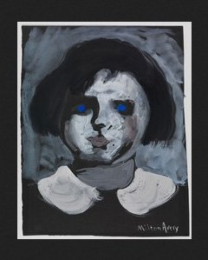
His painting shows a woman whose features have been exaggerated. Her eyes are completely blue and her round face is mostly deathly white. The blue eyes make it hard for one to make her expression. As a result she looks expressionless and staring into the unknown. She is mysterious; some would even say she’s scary (Araslı et al., 192). The background also is a gloomy white. The fact that it is untitled could imply that the artist wanted the viewer to discern for himself what to call it. I would call it “staring into the unknown” due to her eyes. The lady seems to be wearing a dress that was common for the women of Avery’s time so maybe this was how he saw women at the time. Milton Avery used abstract art in his work as according to Barbara Haskell “Avery combined an engagement with purely aesthetic issues with a loyalty to the observed motif. In so doing he bridged the gap between realist and abstract art.”(www.dcmooregallery.com).
Nonrepresentational art is that which bears no reference to the natural world as we see it. It is also called as nonobjective art. This type of art developed from the search for art’s essence in the wake of the challenge presented by photography (Araslı et al., 201). This type of art is highly subjective as each viewer can have a different observation based on what they see. It’s mostly used to bring forth an artist’s feelings, thoughts and emotions to life through a painting. An example of nonrepresentational art is Samuel M. Adler’s invocation painting shown below. It was painted in 1952 and is currently at the Whitney Museum of American Art (Aubert et al. 254).
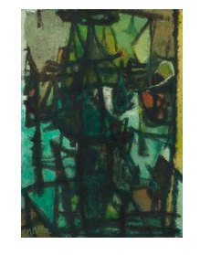
The painting does not resemble anything in the natural world. It’s as if the real painting is hidden behind the thick black lines that cover the painting. You have to look beyond the lines to figure out the painting (Araslı et al., 204). There appears to be a face in the background on the right. Her eyes are shut and she looks sad. The fact that she has no mouth could imply that she has no power or authority over what is happening in her life. This is highly subjective and depends on the viewer. The title of the painting can give a clue. Invocation has several meanings. According to dictionary.com invocation is the act of calling upon a deity, spirit etc for aid, protection etc. The painting could therefore have a spiritual significance hence why the artist chooses to use nonrepresentational method.

Works cited
Araslı, Huseyin, and Hasan Evrim Arıcı. "The art of retaining seasonal employees: three industry-specific leadership styles." The Service Industries Journal 39.3-4 (2019): 175- 205.
Aubert, M., et al. "Palaeolithic cave art in Borneo." Nature 564.7735 (2018): 254-257.
Kalmanowitz, Debra. "Inhabited studio: Art therapy and mindfulness, resilience, adversity and refugees." International Journal of Art Therapy 21.2 (2016): 75-84.
Pelowski, Matthew, et al. "Visualizing the impact of art: An update and comparison of current psychological models of art experience." Frontiers in human neuroscience 10 (2016): 160.
Riemer, Heiko, Stefan Kröpelin, and Andras Zboray. "Climate, styles and archaeology: an integral approach towards an absolute chronology of the rock art in the Libyan Desert (Eastern Sahara)." antiquity 91.355 (2017): 7-23.

